**Department of Electrical Engineering and   
Computer Science**

**Faculty Member:** Dr. Huma Ghafoor  **Dated:** 9/05/2023

**Semester:** 6th **Section:** BEE 12C

**EE-351 Communication Systems**

Lab 11: Pulse Amplitude Modultion

Group Members

|  |  |  |  |  |  |  |
| --- | --- | --- | --- | --- | --- | --- |
| **Name** | **Reg. No** | **Viva / Quiz / Lab Performance** | **Teamwork** | **Ethics** | **Software Tool Usage** | **Analysis of data in Lab Report** |
|  |  | **5 Marks** | **5 Marks** | **5 Marks** | **5 Marks** | **5 Marks** |
| Muhammad Ali Farooq | 331878 |  |  |  |  |  |
| Danial Ahmad | 331388 |  |  |  |  |  |
| Muhammad Umer | 345834 |  |  |  |  |  |
| Tariq Umar | 334943 |  |  |  |  |  |

**Table of Contents**

2 Pulse Amplitude Modulation 3

2.1 Introduction 3

2.2 Advantages: 3

2.3 Lab Report Instructions 4

3 Lab Procedure 5

3.1 Modulation 5

3.2 Demodulation 13

3.3 Deliverables 16

3.3.1 Signal Generation 16

3.3.2 Demodulation 20

4 Conclusion 20

# Pulse Amplitude Modulation

## Introduction

## Advantages:

## Lab Report Instructions

All questions should be answered precisely to get maximum credit. Lab report must ensure following items:

* Lab objective
* Results (screen shots) duly commented and discussed.
* Conclusion

# Lab Procedure

## Modulation

**

## Demodulation

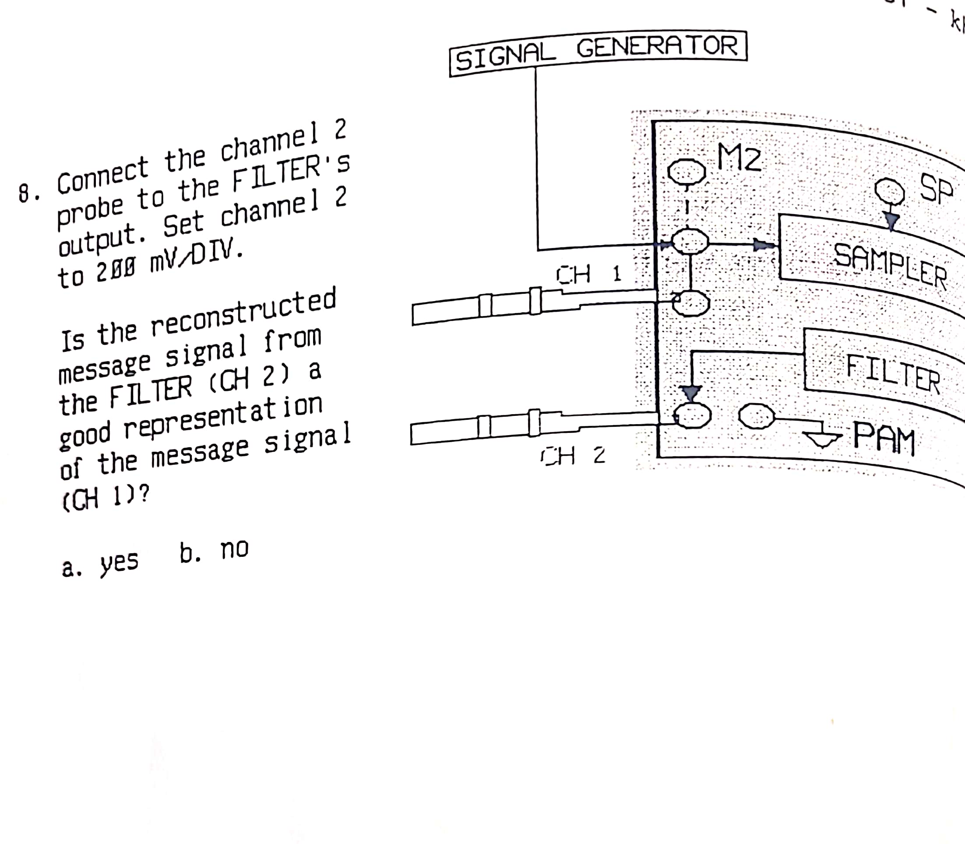

## Deliverables

### Signal Generation

* **Step 2**

**Yes**

* **Step 3**

**4kHz**

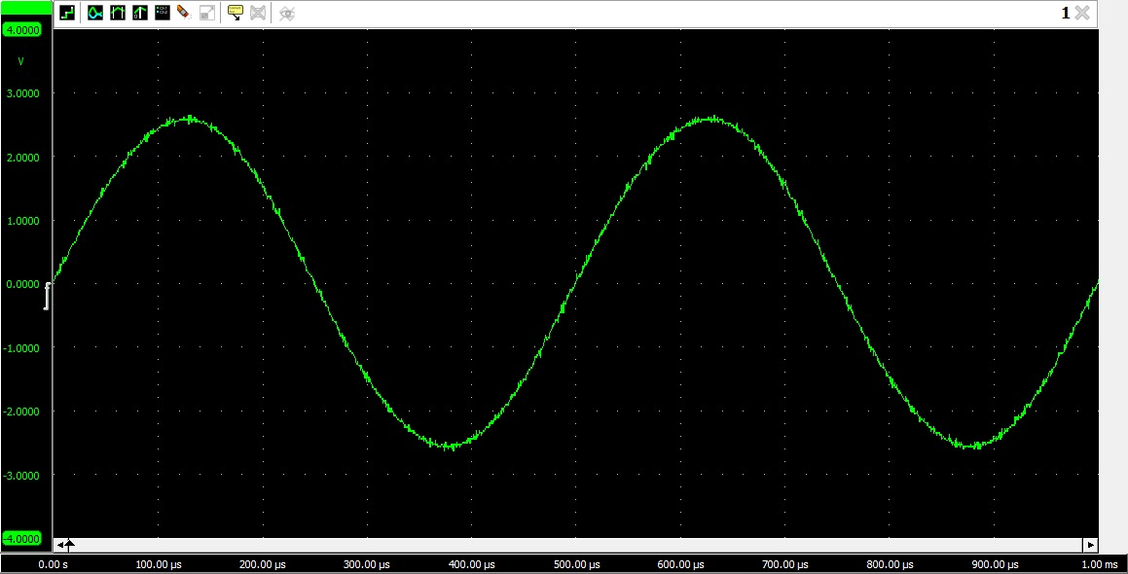

* **Step 5**

**Channel Pulse Signals**

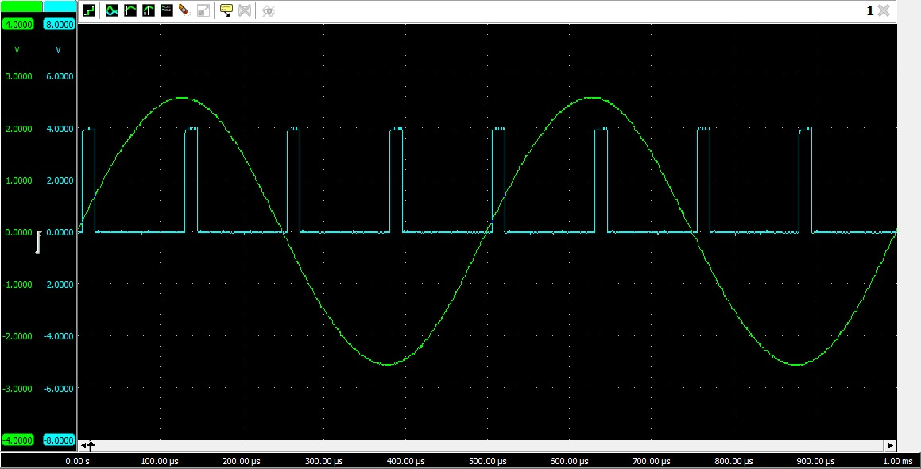

* **Step 6**

**125 us**

* **Step 7**

**8kHz**

* **Step 8**

**Yes**

* **Step 9**

**PAM signal**

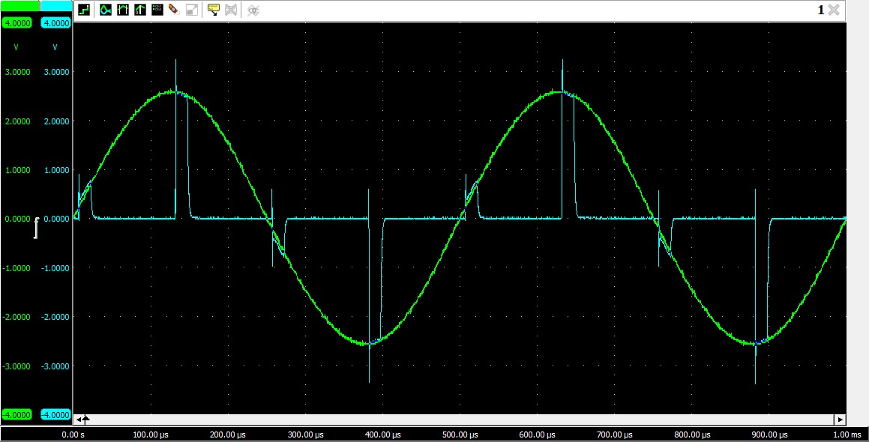

* **Step 10**

**Natural**

* **Step 11**

**Yes**

* **Step 13**

**Yes**

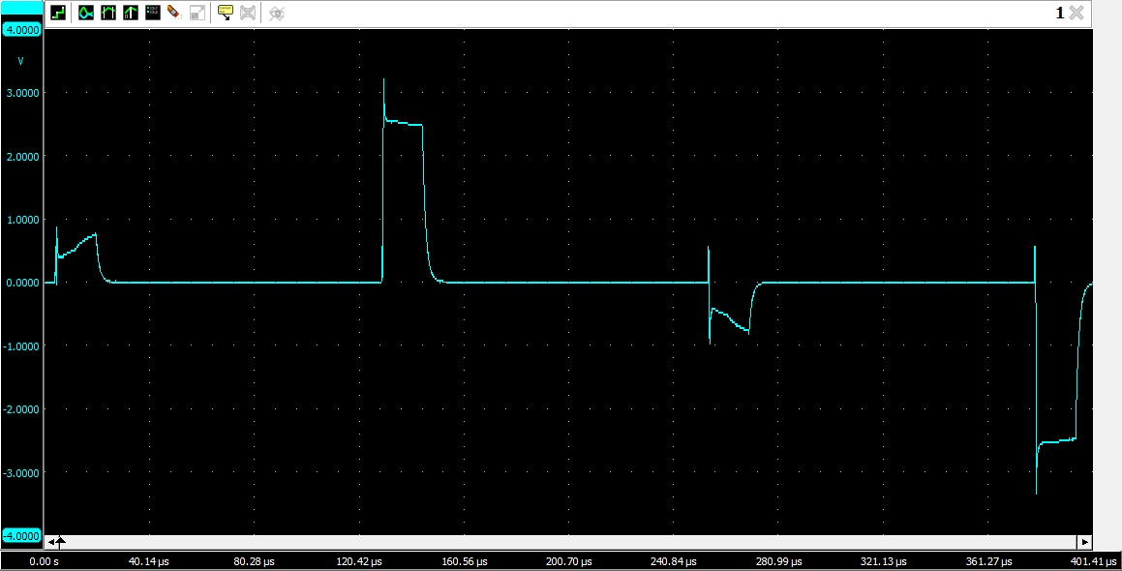

* **Step 21**

**16.679 us**

* **Step 22**

**0.25 ms**

* **Step 23**

**PW / Tp = 0.0667**

* **Step 24**

**2.53 V**

* **Step 25**

**0.53 V**

* **Step 26**

**Vrms = 0.667**

* **Step 27**

**0.445 mW**

* **Step 28**

**3.199 mW**

* **Step 29**

**0.139 W/W**

* **Step 30**

**0.426 mW**

* **Step 31**

**Yes**

### Demodulation

* **Step 4**

**Yes**

* **Step 5**

**Yes**

* **Step 8**

**No**

* **Step 9**

**Yes**

# Conclusion

In conclusion, pulse amplitude modulation (PAM) is a digital modulation technique that represents the information to be transmitted by varying the amplitude of the transmitted pulses. PAM is a versatile modulation technique that can be used for a variety of applications, including telecommunications, data communications, and radar.   
In this lab report, we investigated the characteristics of PAM by generating and analyzing PAM signals. We used a microcontroller to generate PAM signals with different pulse amplitudes and frequencies. We then used an oscilloscope to measure the amplitude and frequency of the PAM signals.  
Our results showed that the amplitude of the PAM signal is proportional to the amplitude of the information signal. We also found that the frequency of the PAM signal is equal to the sum of the frequencies of the information signal and the carrier signal.